Put AU Picture Roster on Desktop
This is a procedure for downloading the AU member roster (with pictures) to the W10 desktop. The roster is opened using MS Internet browser EDGE to enable searching for a name.
- Shows how to get to the AU member roster on the AU webpage
- Demonstrates downloading the roster to your desktop
- Shows how to open the roster in MS EDGE
Open the Internet browser and enter the AU webpage address. Click on the “Membership” item.
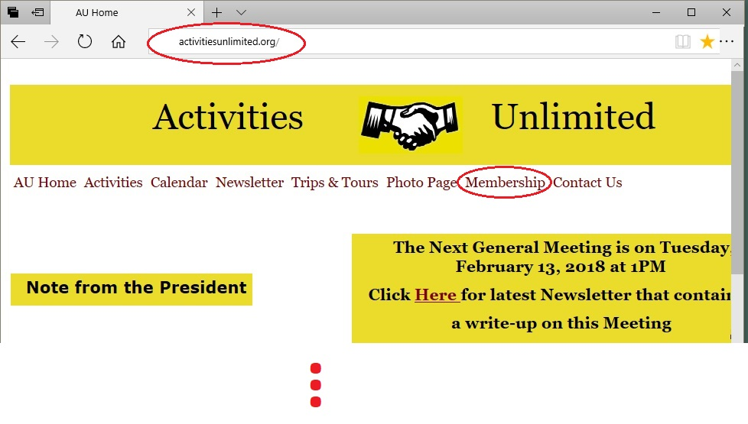
On the membership page scroll down to item “Secured Page” and click
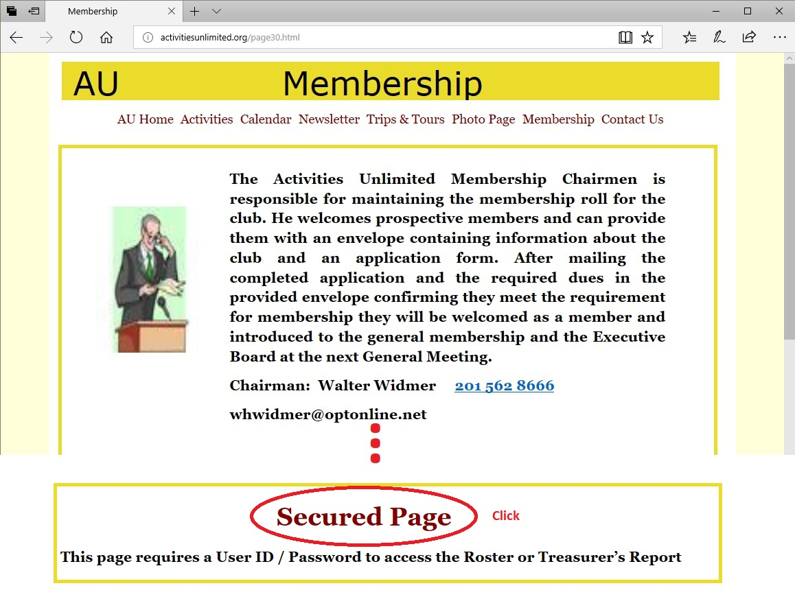
This will request a login from you as shown below:
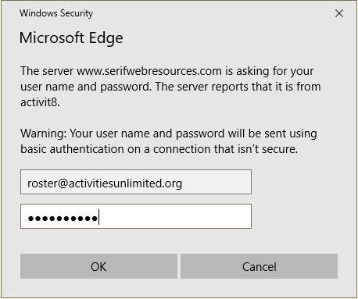
On the Secured Page click on “Membership List with Photos”
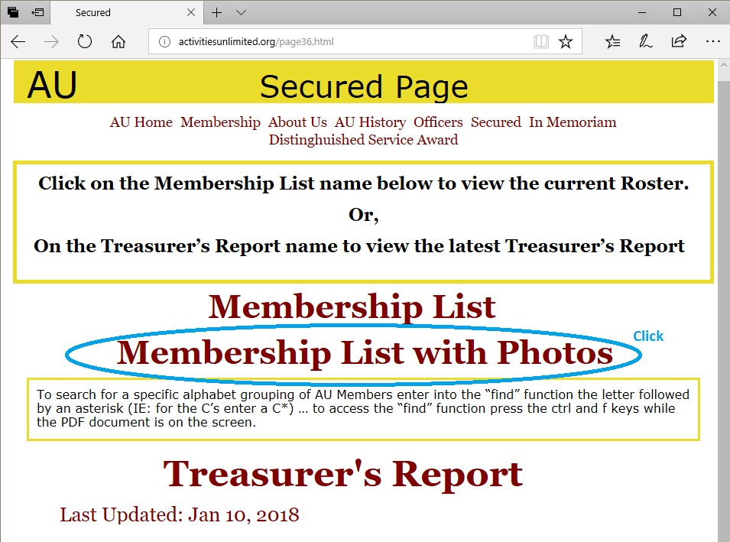
To download the roster – click at top of report to see the menu. Then click SaveAs picture.
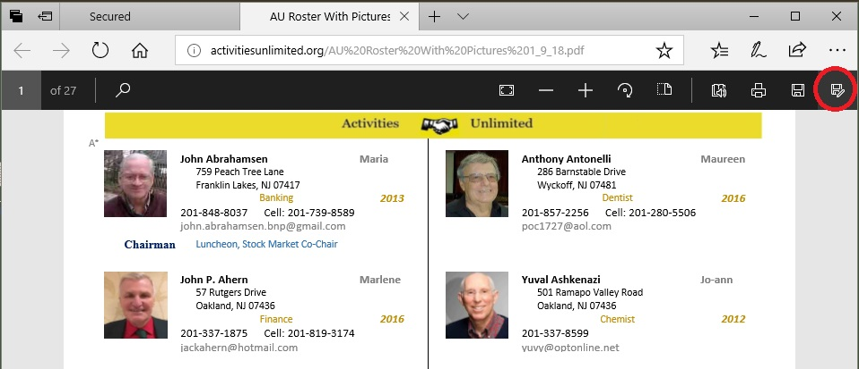
The Windows file save window will appear. Click on “Desktop” then Click the “Save” button.
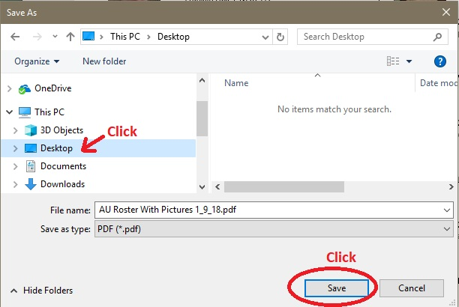
On the Desktop find the ICON of the “AU Roster With Pictures” and RIGHT-CLICK the ICON.
Then click “Open with” drop down menu and click on “Microsoft Edge”
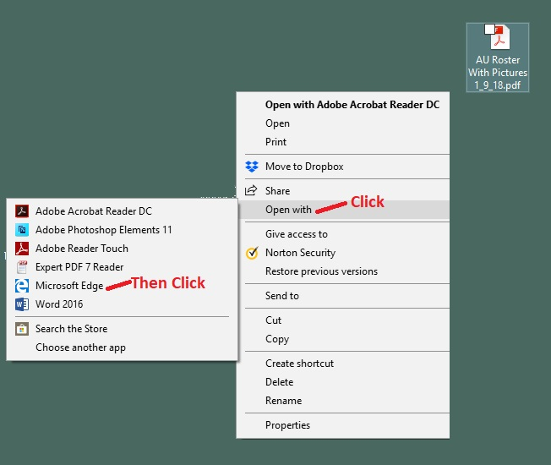

The Roster appears in the browser:
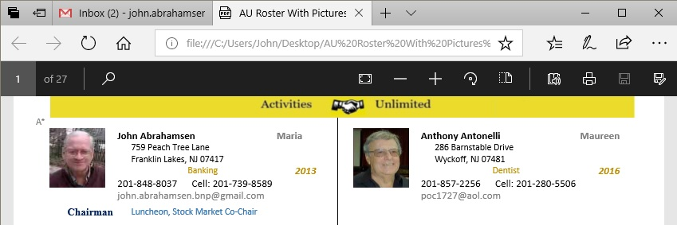
Click top of doc to get menu

Get “Find on page” by clicking Spy Glass. Enter “W*” to move to the W’s.
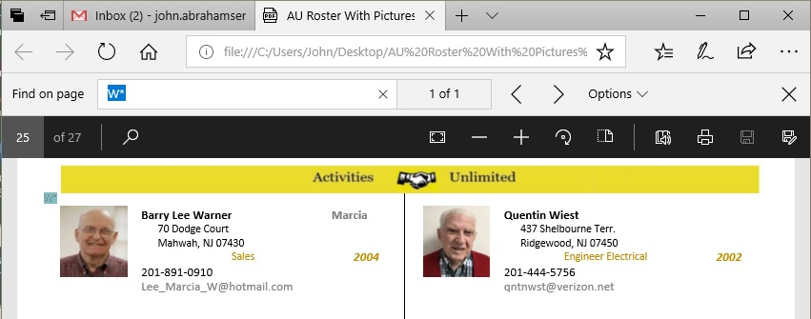
Click spy glass picture

